**Hardware Test:**

***Description:***This test is to ensure that the sensors being used are working effectively. The sensors used are a temperature sensor and a humidity sensor.

***Type:*** White box test.

***Setup:***

1. A Raspberry Pi 3 was used as the micro controller. The temperature sensor was connected to a 10K Ohm pull down resistor in order to read data. The sensor is also connected to 3.3V on the Pi and ground on the Pi.
2. A Python script was written that reads the temperature and humidity from GPIO pins on the Pi. Once the temperature is read is it fed to the backend database.

***Results:***

1. Temperature, humidity, data and time is printed out when the script is run.
2. The same data points are then updated on the database.

**Database Test:**

***Description:***This test is to ensure that the database is running and that data is being updated

***Type:*** White box test.

***Setup:***

***Results:***

1. Database updated after the script is run.
2. Results are displayed in the mysql database.

**APPENDIX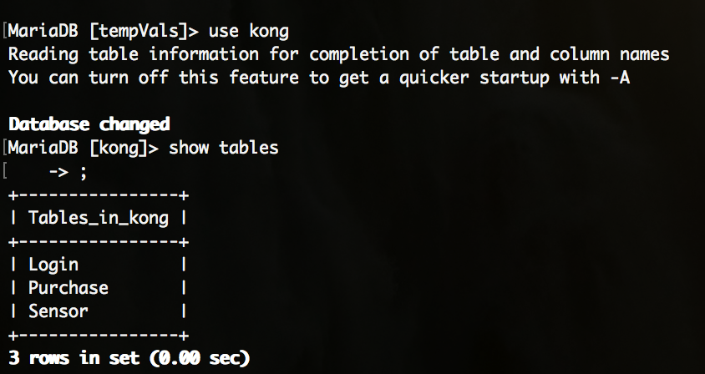***Figure 1. ‘Kong’ Database Table.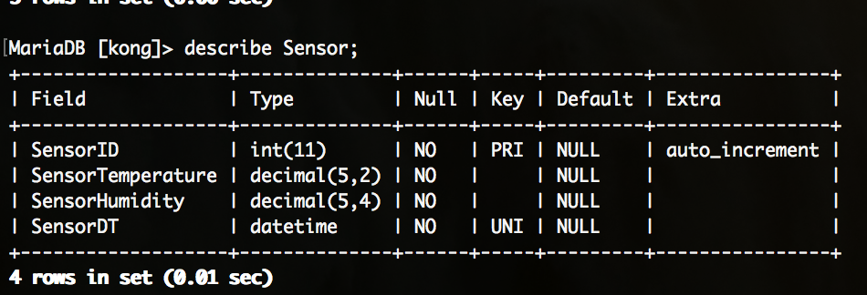*

*Figure 2. ‘Kong’ Database, ‘Sensor’ Table data types.*

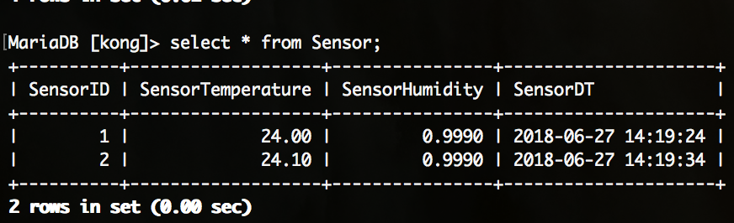

*Figure 3. ‘Kong’ Database, ‘Sensor’ Table imported data.*

*Figure 4. Running script.*

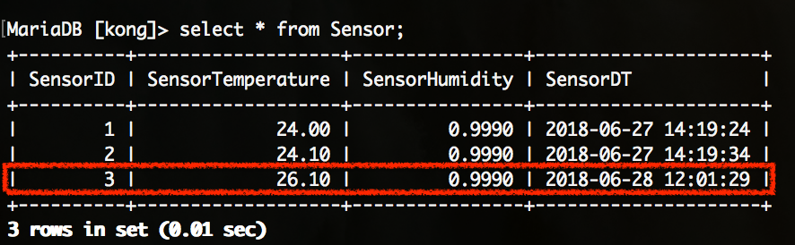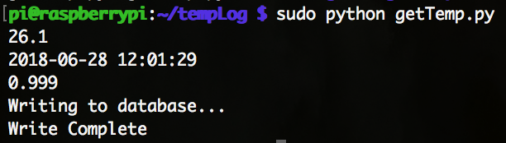

*Figure 5. ‘Kong’ Database, ‘Sensor’ table, updated data after script run.*